**Top 10 AI Business Ideas For 2025**

As artificial intelligence continues to evolve, its potential to reshape industries and create new business opportunities is growing exponentially. By 2025, AI is expected to drive unprecedented innovation across sectors like healthcare, finance, retail, and more. From advanced automation solutions that streamline operations to personalized customer experiences powered by AI, the possibilities are endless. Entrepreneurs and businesses that harness AI’s capabilities can gain a competitive edge, reduce costs, and deliver enhanced value to their customers.

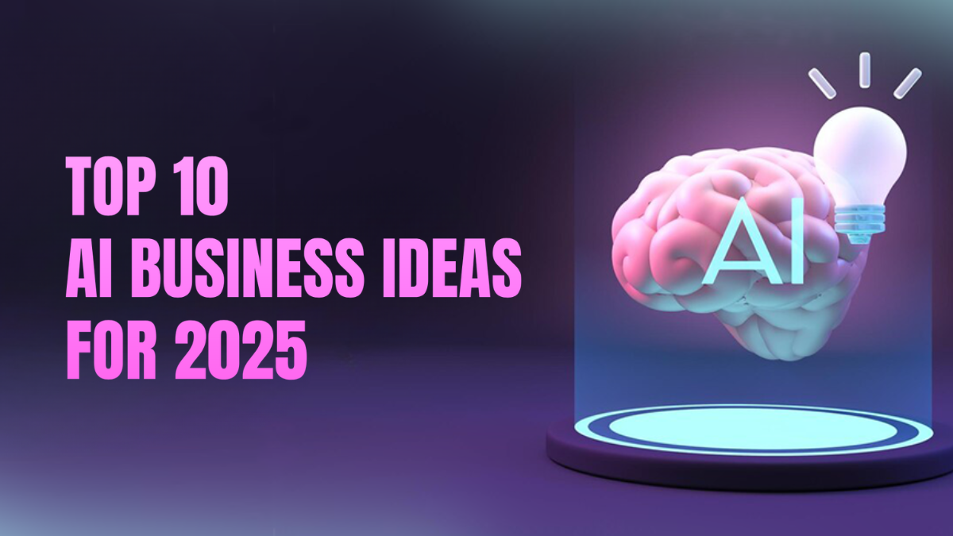

**Fig: AI Business Ideas**

In this article, we explore the top 10 AI business ideas that are set to thrive in 2025, offering insight into emerging trends and strategies for success. Whether you’re looking to enter the AI space or simply enhance your current operations, these ideas will help you stay ahead of the curve and capitalize on the rapidly growing demand for AI-driven solutions. With the right approach, these ideas can transform industries, increase efficiency, and create groundbreaking products and services that shape the future of business.

**Table of Content**

[***What is Artificial Intelligence?***](https://medium.com/cryptoniche/top-10-ai-business-ideas-for-2025-4879bd7eba9c#de63)[***Top 10 AI Business Ideas For 2025***](https://medium.com/cryptoniche/top-10-ai-business-ideas-for-2025-4879bd7eba9c#78b5) ***·*** [***1. AI-Powered Healthcare Platforms***](https://medium.com/cryptoniche/top-10-ai-business-ideas-for-2025-4879bd7eba9c#2ee6) ***·*** [***2. AI-Driven Cybersecurity Solutions***](https://medium.com/cryptoniche/top-10-ai-business-ideas-for-2025-4879bd7eba9c#2fe7) ***·*** [***3. AI in Sustainable Energy Management***](https://medium.com/cryptoniche/top-10-ai-business-ideas-for-2025-4879bd7eba9c#1fe9) ***·*** [***4. AI-Powered Personalized Marketing Platforms***](https://medium.com/cryptoniche/top-10-ai-business-ideas-for-2025-4879bd7eba9c#8f9a) ***·*** [***5. AI-Enhanced Supply Chain Optimization***](https://medium.com/cryptoniche/top-10-ai-business-ideas-for-2025-4879bd7eba9c#7eeb) ***·*** [***6. AI-Powered Financial Advisory and Investment Platforms***](https://medium.com/cryptoniche/top-10-ai-business-ideas-for-2025-4879bd7eba9c#f6b0) ***·*** [***7. AI for Smart Cities and Urban Planning***](https://medium.com/cryptoniche/top-10-ai-business-ideas-for-2025-4879bd7eba9c#c6dc) ***·*** [***8. AI-Enhanced Education and Learning Platforms***](https://medium.com/cryptoniche/top-10-ai-business-ideas-for-2025-4879bd7eba9c#f844) ***·*** [***9. AI in Retail and E-commerce***](https://medium.com/cryptoniche/top-10-ai-business-ideas-for-2025-4879bd7eba9c#d970) ***·*** [***10. AI-Powered Legal Services***](https://medium.com/cryptoniche/top-10-ai-business-ideas-for-2025-4879bd7eba9c#211f)[***Conclusion***](https://medium.com/cryptoniche/top-10-ai-business-ideas-for-2025-4879bd7eba9c#913a)

**What is Artificial Intelligence?**

Artificial Intelligence (AI) refers to the development of computer systems that can perform tasks typically requiring human intelligence. These tasks include learning, reasoning, problem-solving, understanding language, recognizing patterns, and even making decisions. AI works by using algorithms and data to mimic cognitive functions, enabling machines to “learn” from experience and improve their performance over time without explicit programming.

There are different types of AI, ranging from narrow AI, which is designed for specific tasks like speech recognition or image processing, to more advanced forms like general AI, which aims to replicate human-like intelligence across a wide range of activities. AI applications are already transforming industries such as healthcare, finance, and transportation by improving efficiency, reducing costs, and enabling innovations that were previously unimaginable. As AI technology continues to advance, it holds the potential to reshape the future of how we live and work, driving progress in numerous fields and enhancing human capabilities in unprecedented ways.

**Top 10 AI Business Ideas For 2025**

As AI continues to revolutionize industries, innovative business ideas are emerging at the intersection of technology and market demand. In 2025, AI-driven solutions will create exciting opportunities across various sectors. Here are the [**top 10 AI business ideas**](https://www.blockchainappfactory.com/ai-development-company) poised to shape the future and drive growth.

**1. AI-Powered Healthcare Platforms**

AI-powered healthcare platforms are set to revolutionize the medical industry by 2025. These platforms use advanced algorithms and machine learning models to enhance diagnostics, personalize treatment plans, and improve patient outcomes. AI-driven systems can analyze medical data, including imaging, genetic information, and patient history, to detect diseases earlier and with greater accuracy. Virtual healthcare assistants and telemedicine platforms, empowered by AI, offer personalized care, making healthcare more accessible and efficient.

For entrepreneurs, AI healthcare startups can provide solutions such as automated diagnostic tools, predictive analytics for patient monitoring, and virtual care systems. By 2025, the growing demand for personalized medicine will create opportunities for AI businesses to transform how healthcare is delivered, especially in underserved regions or for individuals with chronic conditions. These platforms will not only optimize patient care but also significantly reduce costs, paving the way for affordable healthcare systems globally.

The pandemic accelerated the adoption of digital health solutions, and AI-powered platforms are crucial in addressing ongoing healthcare challenges, such as the rise of chronic diseases and aging populations. As AI becomes more advanced, its integration with healthcare platforms will lead to precision medicine, reduced medical errors, and improved patient satisfaction, making this an essential business idea for 2025.

**2. AI-Driven Cybersecurity Solutions**

As businesses and governments continue to digitalize their operations, the demand for robust cybersecurity solutions is growing exponentially. AI-driven cybersecurity solutions leverage machine learning algorithms to detect, prevent, and respond to cyber threats in real-time, far faster than traditional methods. These systems can continuously learn from emerging attack patterns, analyzing vast amounts of data to recognize potential vulnerabilities and prevent breaches before they occur.

By 2025, the cybersecurity landscape will be even more complex with an increasing number of sophisticated attacks, including ransomware, phishing, and AI-based hacking. Businesses providing AI-driven cybersecurity services will be in high demand as industries such as finance, healthcare, and retail require advanced, real-time protection to safeguard sensitive information.

AI’s ability to automate threat detection and response provides significant advantages, reducing the need for human intervention and improving accuracy in identifying potential risks. AI-driven cybersecurity solutions will be indispensable, especially for small and medium-sized businesses, which often lack the resources for dedicated cybersecurity teams. Entrepreneurs can build AI-powered platforms that provide security as a service, enabling companies of all sizes to protect their digital assets. The importance of cybersecurity in a hyperconnected world makes it one of the top AI business ideas for 2025.

**3. AI in Sustainable Energy Management**

With the global shift towards renewable energy and sustainability, AI will play a pivotal role in managing energy resources more efficiently. AI can optimize energy consumption, predict demand patterns, and integrate renewable energy sources like wind and solar into existing grids. By analyzing historical and real-time data, AI systems can anticipate energy needs, optimize supply chains, and reduce waste, making energy systems smarter and more sustainable.

For businesses, AI-powered platforms in energy management can focus on smart grids, energy storage solutions, or intelligent energy consumption systems for homes and industries. As governments worldwide push for net-zero emissions, demand for AI-driven solutions that improve energy efficiency and lower carbon footprints will soar. AI can also help manage decentralized energy production, ensuring that renewable sources are utilized efficiently.

The integration of AI in sustainable energy management will be crucial for reducing environmental impacts while keeping energy costs down. Entrepreneurs can develop AI platforms for smart buildings, predictive maintenance of energy infrastructure, or AI solutions for large-scale energy producers. The increasing focus on sustainability and climate change will create a fertile environment for AI-driven innovation in energy management by 2025.

**4. AI-Powered Personalized Marketing Platforms**

In 2025, businesses will heavily rely on AI-powered personalized marketing platforms to create tailored experiences for customers. These platforms use machine learning algorithms to analyze customer behavior, preferences, and purchasing history to deliver highly targeted marketing messages. Personalized recommendations, dynamic content, and predictive analytics help brands engage consumers in more meaningful ways, driving customer loyalty and increasing sales.

Entrepreneurs can capitalize on this trend by developing AI-driven platforms that enable businesses to automate and optimize their marketing strategies. From personalized email campaigns to real-time website customization, AI can help marketers predict customer needs and deliver content that resonates on a deeper level. Additionally, AI can improve ad targeting, optimizing advertising spend by identifying the most likely customer segments to engage.

As consumers increasingly expect personalized experiences, businesses that leverage AI in marketing will have a competitive edge. AI-driven platforms can also provide businesses with deep insights into customer behavior, helping them refine their products and services. By automating the process of analyzing data and delivering personalized content, AI will transform marketing into a highly efficient and effective business tool, making it one of the top AI business ideas for 2025.

**5. AI-Enhanced Supply Chain Optimization**

AI-powered solutions for supply chain optimization are set to transform logistics and operations by 2025. Supply chains, which have grown increasingly complex due to globalization, require advanced technology to ensure efficiency, reduce costs, and meet the demands of fast-paced markets. AI enhances supply chain management by forecasting demand, identifying potential disruptions, and optimizing routes for logistics, leading to better decision-making.

AI-based systems can process real-time data, such as weather, traffic, and geopolitical events, to make supply chains more resilient and adaptive. This helps companies mitigate risks, reduce delays, and improve customer satisfaction. Entrepreneurs can create platforms that offer predictive analytics, smart warehousing, and real-time monitoring, helping businesses stay agile in dynamic markets.

In addition to improving efficiency, AI-powered supply chain solutions can also reduce environmental impacts by optimizing fuel consumption and minimizing waste. With sustainability becoming a key focus for many industries, AI’s role in greening the supply chain is likely to grow. As businesses look for ways to cut costs and improve sustainability, AI-enhanced supply chain platforms will be in high demand, making this one of the top AI business ideas for 2025.

**6. AI-Powered Financial Advisory and Investment Platforms**

AI is transforming the financial services industry by making personalized financial advice and investment management accessible to a broader audience. AI-powered financial platforms, such as robo-advisors and automated trading systems, use machine learning to analyze market trends, assess risks, and provide tailored financial recommendations to individuals and businesses.

By 2025, AI-driven financial advisory platforms will offer sophisticated services such as real-time portfolio management, automated wealth management, and personalized financial planning. These platforms can continuously analyze data from global markets, helping investors make informed decisions based on data-driven insights rather than relying solely on human expertise.

Entrepreneurs can seize the opportunity by developing AI-powered platforms that democratize financial advice, providing cost-effective solutions to retail investors who may not have access to traditional wealth management services. Additionally, AI can help reduce biases in investment decisions and optimize portfolios based on individual risk preferences.

As more individuals and businesses seek data-driven financial solutions, the demand for AI-powered platforms in the financial sector will grow. This creates an opportunity for startups to disrupt traditional financial advisory services and provide more accurate, personalized, and cost-efficient financial planning.

**7. AI for Smart Cities and Urban Planning**

The concept of smart cities, where technology is integrated into urban infrastructure, will be heavily influenced by AI by 2025. AI-powered systems can optimize traffic flow, manage resources, and improve public safety in real-time, making cities more efficient, sustainable, and livable. From smart grids that monitor energy consumption to AI-powered public transportation systems that reduce congestion, AI will revolutionize how cities operate.

Entrepreneurs can develop AI solutions that cater to urban planning, such as AI-powered platforms for city management, real-time monitoring of infrastructure, and smart building technologies. These solutions can help cities reduce energy waste, improve waste management, and enhance emergency response times by analyzing vast amounts of urban data.

As urbanization continues to rise, the demand for smarter, more efficient cities will grow, creating significant opportunities for AI-based businesses. Governments and municipalities are likely to invest in AI solutions to solve the challenges of population growth, traffic congestion, and resource management. With the global push for sustainability, AI-driven smart city solutions will be a crucial component in building the cities of the future.

**8. AI-Enhanced Education and Learning Platforms**

Education is undergoing a digital transformation, and by 2025, AI-enhanced learning platforms will be at the forefront of this change. These platforms use AI to provide personalized learning experiences, adapting to the needs of individual students. From automated grading to intelligent tutoring systems that offer real-time feedback, AI can enhance the learning process for students of all ages.

AI-driven platforms can also analyze student performance, identifying areas where learners struggle and tailoring content to address gaps in knowledge. Entrepreneurs can build AI-powered education platforms that offer adaptive learning pathways, virtual classrooms, and personalized study plans, making education more accessible and effective.

With the rise of online education, particularly following the COVID-19 pandemic, the demand for AI-enhanced learning solutions is expected to grow. AI can also play a role in corporate training, helping employees upskill by providing personalized learning modules. As education becomes more digital, AI-driven platforms will transform how individuals learn, making education more flexible and accessible. This is a major business opportunity for 2025.

**9. AI in Retail and E-commerce**

AI is set to transform the retail and e-commerce sectors by 2025, enhancing customer experiences and streamlining operations. AI-driven recommendation engines, virtual shopping assistants, and personalized product suggestions will enable retailers to provide tailored shopping experiences, improving customer satisfaction and driving sales. In addition to customer experience, AI will also optimize inventory management, pricing strategies, and supply chain logistics.

Entrepreneurs can create AI-powered retail solutions that enhance various aspects of the retail experience, from customer service bots that provide instant assistance to AI systems that analyze purchasing patterns and optimize stock levels. E-commerce platforms can use AI to predict trends, manage returns, and offer dynamic pricing based on real-time market data.

As consumers increasingly expect seamless, personalized shopping experiences, retailers that leverage AI will have a significant competitive advantage. Moreover, AI can automate many routine tasks, reducing operational costs and improving efficiency. With the continued growth of online shopping and the push for more efficient retail operations, AI will play a pivotal role in shaping the future of retail, making it a top business idea for 2025.

**10. AI-Powered Legal Services**

By 2025, AI will disrupt the legal industry by automating tasks such as document review, contract analysis, and legal research. AI-powered legal platforms can analyze vast amounts of legal data, identify patterns, and provide insights that help lawyers make informed decisions faster. These platforms will improve efficiency, reduce costs, and make legal services more accessible to small businesses and individuals.

Entrepreneurs can develop AI-powered legal tools that offer contract management, automated legal research, and even predictive analytics for case outcomes. Such platforms can also assist law firms in managing cases, streamlining administrative tasks, and reducing the time required to complete routine legal work.

With the legal industry becoming more complex and data-driven, AI will be instrumental in providing faster, more affordable legal services. Small firms and startups can leverage AI to compete with larger firms by offering high-quality services at lower costs. As AI continues to evolve, its applications in the legal sector will expand, making it a key business area for innovation in 2025.

**Conclusion**

The AI landscape in 2025 promises to be a fertile ground for innovation, with endless opportunities for businesses to thrive. As AI continues to transform industries, adopting one of the top 10 AI business ideas can position your company at the forefront of technological advancement. Whether through automation, personalized services, AI-driven analytics, or intelligent customer support, these ideas provide a roadmap for success in a competitive marketplace. The key to leveraging AI effectively lies in staying agile, understanding the needs of your market, and continuously adapting to technological advancements.

By investing in AI solutions, businesses can not only streamline operations and reduce costs but also deliver superior value and experiences to customers. The future of AI in business is rich with potential, and those who act early will reap the rewards of innovation. Embrace the power of AI, and you’ll be well-equipped to shape the future of your industry, unlock new revenue streams, and lead the way into the next era of business.